* 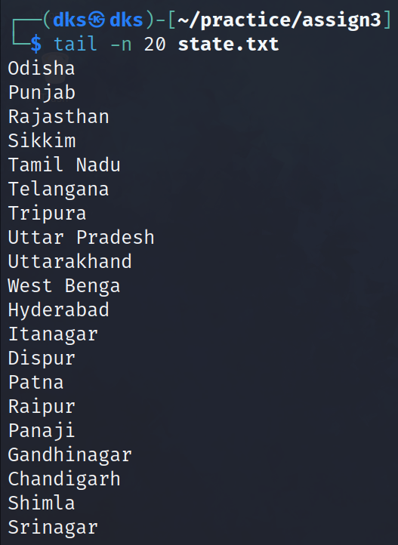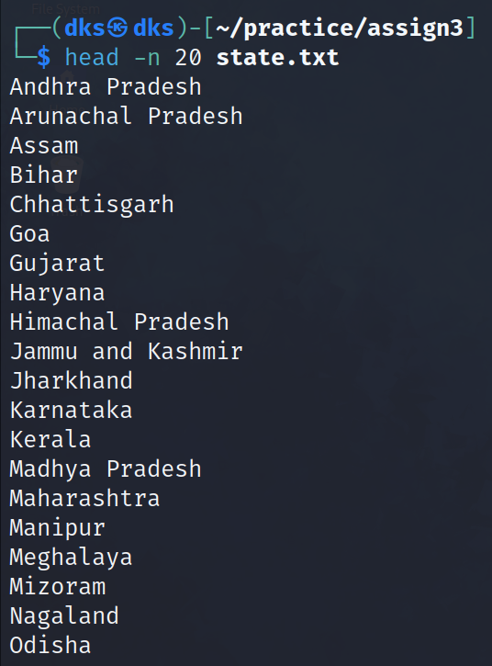Inspect the first and last 20 lines of the file, using "head" and "tail" functions to retrieve first and last lines of the file.
* 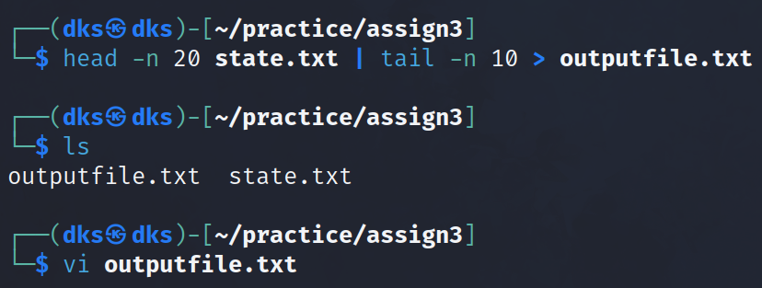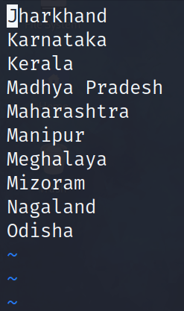Retrieve line number 11 to 20 from a file and write these lines into a new file.
* Inspect the columns 2, 3 and 5 of lines using "cut" function to specify the columns.
* Count the total number of lines in the file.
* Sort the contents of the file and create a new file of that contents
* Use Grep command for

a) Print all lines that contains a phrase.

b) Print the lines with line numbers .

c) To put this in context, print the two lines before it along with the line.

d) Print the lines that starts with a character.

e) Print the lines that ends with a character.

* Display the entire .conf file in your etc directory
* Show how you will find any random file with name in the entire system
* How will you find a random file with its name in your current directory ?
* How can we find a file with its extension?
* Display all files in your system with the privilege of 777.
* Show the files in your system which was modified before 6 days.
* Display the files in any random directory which have got modified with in less than last 2 hours
* Demonstrate the difference between Locate and Find with an example